**INDEX**

|  |  |  |  |
| --- | --- | --- | --- |
| **S. No.** | **Name of Experiments** | **Page No.** | |
|  | **BASIC PROGRAMS** |  | |
| 1 | Write a python program to print "Hello". |  | |
| 2 | Write a python program to add, subtract, multiply & divide two numbers. |  | |
| 3 | Write a python program to find percentage of students. |  | |
| 4 | Write a python program to swap two numbers using a temporary variable |  | |
| 5 | Write a python program to swap two numbers without using a temporary variable |  | |
| 6 | Write a python program to calculate factorial of a number. |  | |
| 7 | Write a python program to take user input. |  | |
|  | I**F-ELSE** |  | |
| 8 | Write a python program to accept two integers and check whether they are equal or not |  | |
| 9 | Write a python program to program to find even and odd number. |  | |
| 10 | Write a python program to find greatest among three numbers. |  | |
| 11 | Write a python program to check whether a given number is positive or negative |  | |
| 12 | Write a python program to check whether entered character is vowel or consonant. |  | |
| 13 | Write a python program to check result of student(Pass or Fail) |  | |
| 14 | Write a python program to find whether a given year is a leap year or not |  | |
|  |  |  | |
|  | **LOOPS** |  | |
| 15 | Write a python program to display numbers from 1 to 100 using a loop |  | |
| 16 | Write a python program to display table of a number taken from user input. |  | |
| 17 | Write a python program to print factorial of a number received as a user input. |  | |
| 18 | Write a python program to find Fibonacci series up to n terms |  | |
| 19 | Write a python program to generate prime numbers from 1 to 50. |  | |
|  |  |  | |
|  | **LIST** |  | |
| 20 | Write a python program to create a list. |  | |  | |
| 21 | Write a python program to access elements of a list. |  | |  | |
| 22 | Write a python program to print even numbers present in a list. |  | |  | |
| 23 | Write a python program to multiplies all the items in a list. .. |  | |  | |
| 24 | Write a python program to get the smallest number from a list. |  | |  | |
| 25 | Write a python program to get the largest number from a list. |  | |  | |
|  |  |  | |  | |
|  |  |  | |  | |
|  | **TUPLE** |  | |  | |
| 26 | Write a python program to create a tuple. |  | |  | |
| 27 | Write a python program to create a tuple with numbers and print one item |  | |  | |
| 28 | Write a python program to add an item in a tuple |  | |  | |
| 29 | Write a python program to convert a list to a tuple |  | |  | |
| 30 | Write a python program to find the length of a tuple |  | |  | |
|  |  |  | |  | |
|  | **SET** |  | |  | |
| 31 | Write a Python program to create a set |  | |  | |
| 32 | Write a Python program to add member(s) in a set |  |  | |  | |
| 33 | Write a Python program to remove item(s) from set |  |  | |  | |
| 34 | Write a Python program to create an intersection of sets |  |  | |  | |
| 35 | Write a Python program to create a union of sets |  |  | |  | |
| 36 | Write a Python program to create set difference |  |  | |  | |
| 37 | Write a Python program to clear a set |  |  | |  | |
|  |  |  |  | |  | |
|  | **DICTIONARY** |  |  | |  | |
| 38 | Write a Python program to create a dictionary |  |  | |  | |
| 39 | Write a Python program t to add a key to a dictionary |  |  | |  | |
| 40 | Write a Python program to check whether a given key already exists in a dictionary. |  |  | |  | |
| 41 | Write a Python program to merge two Python dictionaries |  |  | |  | |
| 42 | Write a Python program to sum all the items in a dictionary |  |  | |  | |
|  |  |  |  | |  | |
|  |  |  |  | |  | |
|  | **FUNCTION** |  | |  | |
| 43 | Write a Python function to find average of five numbers passed parameters. |  | |
| 44 | Write a Python function to take list as argument and remove odd numbers from list. |  | |
| 45 | Write a Python function to find Fibonacci series up to n terms |  | |
| 46 | Write a Python function to find factorial of a number using function |  | |
| 47 | Write a Python function to generate a table of any number entered by user. |  | |
| 48 | Write a Python function to check whether given number is prime or composite(using function) |  | |
| 49 | Write a Python function to generate prime numbers from 1 to 100 (using function) |  | |
| 50 | Write a Python function to check whether input number is even or odd. |  | |
| 51 | Write a Python function to sum all the numbers in a list |  | |

**PROGRAM 1.Write a python program to print"Hello".**

print("Hello")

**OUTPUT:**

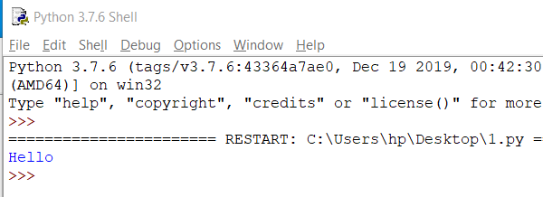

**PROGRAM** **2.Write a python program to add, subtract, multiply and divide two numbers.**

num1=20

num2=10

summ=num1+num2

sub=num1-num2

multiply=num1*num2

divide=num1//num2

print("Sum of the number is:",summ)

print("Subtraction of the number is:",sub)

print("Multiplication of the number is:",multiply)

print("Division of the number is:",divide)

**OUTPUT:**

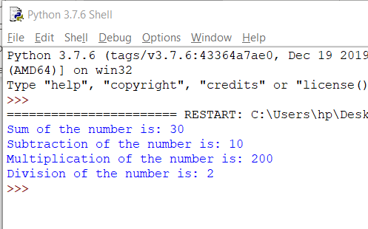

**PROGRAM 3.Write a python program to find percentage of a student.**

print("Marks obtained by student in each subject out of 100:")

total_marks=0

hindi=90

english=80

maths=70

social_science=60

science=50

print("Hindi:90")

print("English:80")

print("Maths:70")

print("Social Science:60")

print("Science:50")

total_marks+=hindi+english+maths+social_science+science

print("Total marks obtained by student out of 500:\n",total_marks)

per=total_marks*(100/500)

print("Percentage:",per)

**OUTPUT:**

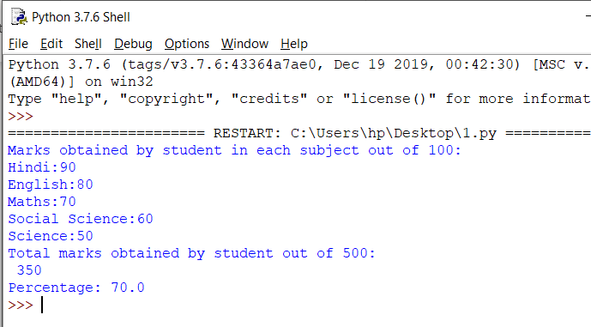

**PROGRAM 4.Write a python program to swap two numbers using temporary variable.**

a=10

b=20

print("Before swapping")

print(a)

print(b)

c=a

a=b

b=c

print("After swapping")

print(a)

print(b)

**OUTPUT:**

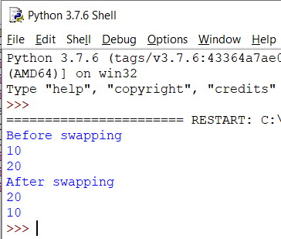

**PROGRAM 5.Write a python program to swap two numbers without using temporary variable.**

a=20

b=10

print("Before swapping")

print(a)

print(b)

a=a+b

b=a-b

a=a-b

print("After swapping")

print(a)

print(b)

**OUTPUT:**

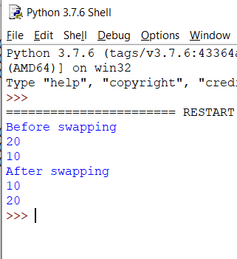

**PROGRAM 6.Write a python program to calculate factorial of a number**

num=5

fact=1

total=0

for i in range(0,5,1):

total=fact*num

fact=total

num-=1

print("Factorial of a number is:",fact)

**OUTPUT:**

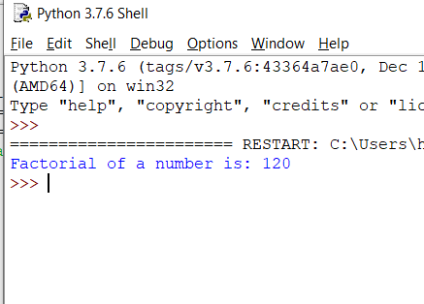

**PROGRAM 7.Write a python program to take user input.**

num=int(input("Enter the number\n"))

string=input("Enter the string\n")

print("Number:",num)

print("String:"+string)

**OUTPUT:**

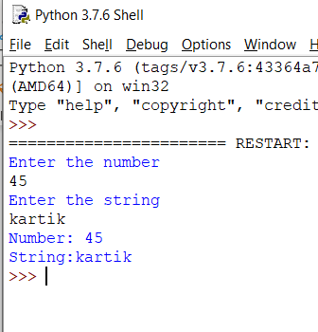

**PROGRAM 8.Write a python program to accept two integers and check wheather they are equal or not.**

num1=int(input("Enter the first number "))

num2=int(input("Enter the second number "))

if num1==num2:

print("EQUAL")

else:

print("UNEQUAL")

**OUTPUT:**

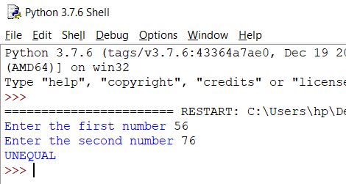

**PROGRAM 9.Write a python program to find even and odd.**

num=int(input("Enter the number "))

if num%2==0:

print("EVEN")

else:print("ODD")

**OUTPUT:**

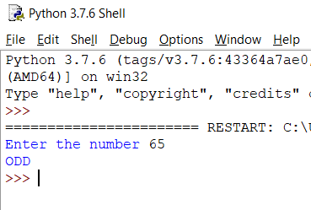

**PROGRAM 10.Write a python program to find greatest among three numbers.**

num1=int(input("Enter the first number "))

num2=int(input("Enter the second number "))

num3=int(input("Enter the third number "))

if num1>num2 and num1>num3:

print("First number is Greater")

elif num2>num1 and num2>num3:

print("Second number is Greater")

else:

print("Third number is Greater")

**OUTPUT:**

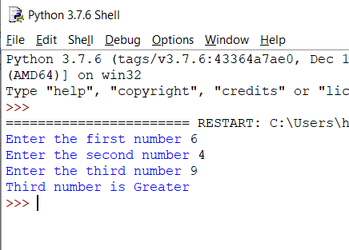

**PROGRAM 11.Write a python program to check whether a given number is positive or negative.**

num=int(input("Enter the number "))

if num>0:

print("Positive")

elif num<0:

print("Negative")

else:

print("Neutral")

**OUTPUT:**

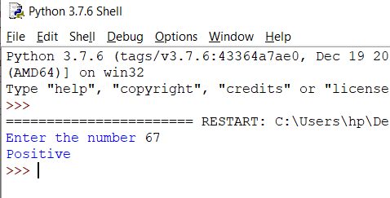

**PROGRAM 12.Write a python program to check whether entered character is vowel or consonant**.

char=input("Enter the character ")

if char=='a' or char=='e' or char=='i' or char=='o' or char=='u' or char=='A' or char=='E' or char=='I' or char=='O' or char=='U':

print("VOWEL")

else:

print("CONSONANT")

**OUTPUT:**

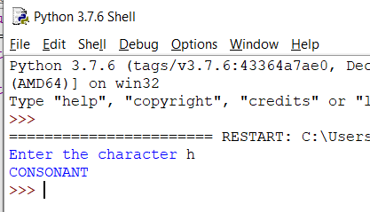

**PROGRAM 13.Write a python program to check result of student(pass or fail).**

total_marks=0

hindi=float(input("Enter the marks of Hindi out of 100:"))

english=float(input("Enter the marks of English out of 100:"))

maths=float(input("Enter the marks of Maths out of 100:"))

social_science=float(input("Enter the marks of Social Science out of 100:"))

science=float(input("Enter the marks of Science out of 100:"))

total_marks+=hindi+english+maths+social_science+science

per=total_marks*(100/500)

if per>0 and per<=33:

print("FAIL")

elif per>33 and per<=100:

print("PASS")

**OUTPUT:**

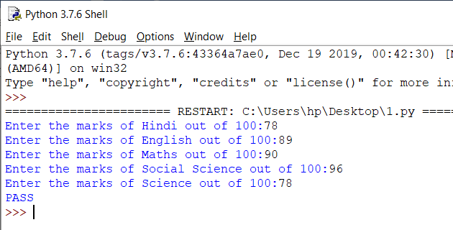

**PROGRAM 14.Write a python program to find a given year is leap or not.**

year=int(input("Enter the year:"))

if year%4==0 and year%100==0 and year%400==0:

print("Leap Year")

else:

print("Not Leap Year")

**OUTPUT:**

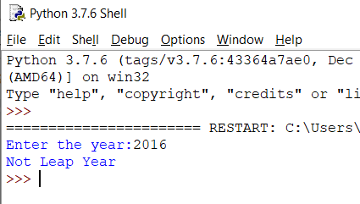

**PROGRAM 15.Write a python program to display numbers from 1 to 100 using loop.**

for i in range(1,101,1):

print(i)

**OUTPUT:**

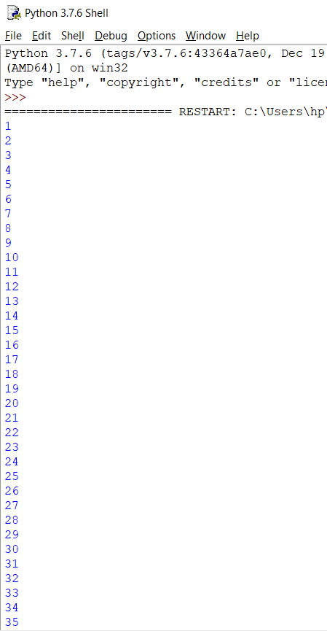

**PROGRAM 16.Write a python program to display table of a number taken from user input.**

num=int(input("Enter the number "))

for i in range(1,11,1):

print(num ,"*", i,"=",num*i )

**OUTPUT:**

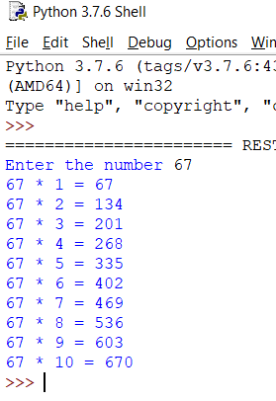

**PROGRAM 17.Write a python program to print factorial of a num received as a user input.**

num=int(input("Enter the number "))

fact=1

total=0

for i in range(0,num,1):

total=fact*num

fact=total

num-=1

print("Factorial:",fact)

**OUTPUT:**

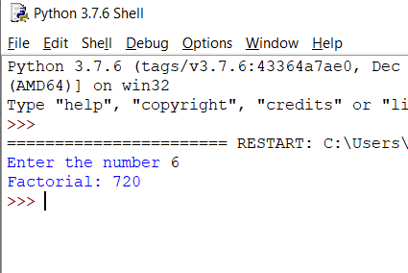

**PROGRAM 18.Write a python program to find fibonacci series upto n terms**.

num=int(input("Enter the number "))

a=0

b=1

print(a,end=" ")

print(b,end=" ")

for i in range(0,num,1):

c=a+b

print(c,end=" ")

a=b

b=c

**OUTPUT:**

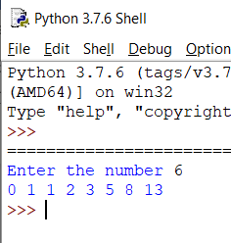

**PROGRAM 19.Write a python program to generate prime number from 1 to 50**.

for num in range(1,51):

count=0

for i in range(2,(num//2+1)):

if (num%i==0):

count+=1

break

if (count==0 and num!=1):

print(num,end=" ")

**OUTPUT:**

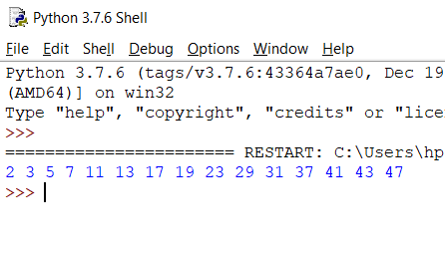

**PROGRAM 20.Write a python to create a list**.

l=[1,2,3,"abc","x","y",5.5,8.9]

for i in l:

print(i)

**OUTPUT:**

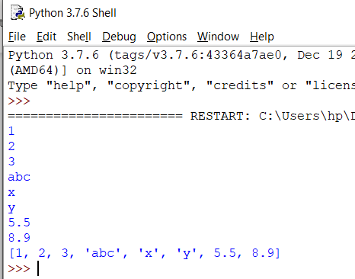

**PROGRAM 21.Write a python program to access elements of list.**

l=[1,2,3,"abc","x","y",5.5,8.9]

print(l[0])

print(l[3])

print(l[4]) #accessing elements of list

print(l[7])

**OUTPUT:**

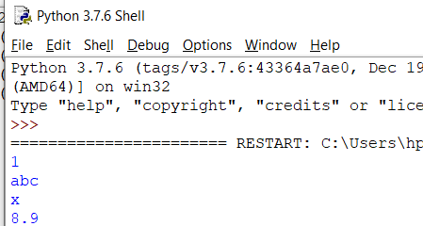

**PROGRAM 22.Write a python program to print even numbers present in list.**

l=[1,2,3,4,5,6,7,8,9,10]

for i in l:

if i%2==0:

print(i)

**OUTPUT:**

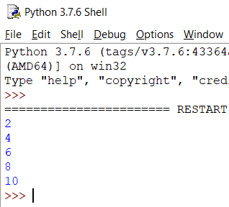

**PROGRAM 23.Write a python program to multiplies all the items in a list**

l=[1,2,3,4,5,6]

num=1

total=0

for i in l:

total=num*i

num=total

print(total)

**OUTPUT:**

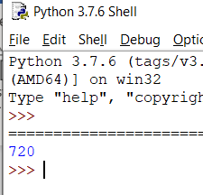

**PROGRAM 24.Write a python program to get the smallest number from list**.

l=[2,4,6,1,9,7]

min_num=min(l)

print("minimum number from list is:",min_num)

**OUTPUT:**

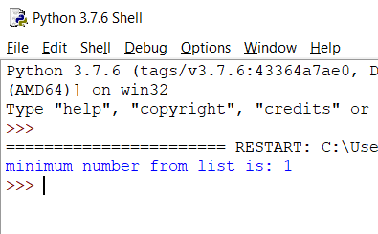

**PROGRAM 25.Write a python program to get the largest number from a list**.

l=[2,4,6,1,9,7]

max_num=max(l)

print("maximum number from list is:",max_num)

**OUTPUT:**

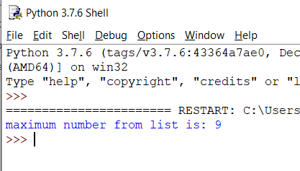

**PROGRAM 26.Write a python program to create a tuple**.

t=(1,2,3,4.4,5.5,'a','b','c','abc','xyz')

print(t)

**OUTPUT:**

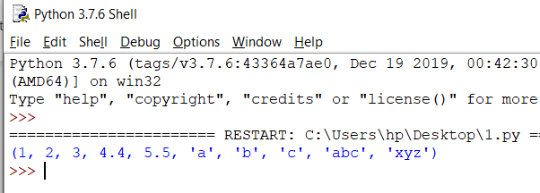

**PROGRAM 27.Write a python program to create a tuple with numbers and print one item.**

t=(1,2,3,4.4,5.5,'a','b','c','abc','xyz')

print(t[3])

**OUTPUT:**

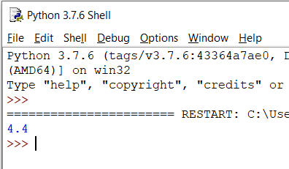

**PROGRAM 28.Write a python program to add an item in a tuple.**

t=(1,2,3,4.4,5.5,'a','b','c','abc','xyz')

l=list(t)

l.append(10)

t=tuple(l)

print(t)

**OUTPUT:**

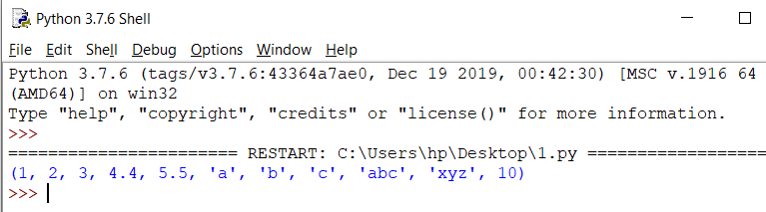

**PROGRAM 29.Write a python program to convert a list to a tuple**.

l=[1,2,3,4.4,5.5,'a','b','c','abc','xyz']

t=tuple(l)

print(t)

**OUTPUT:**

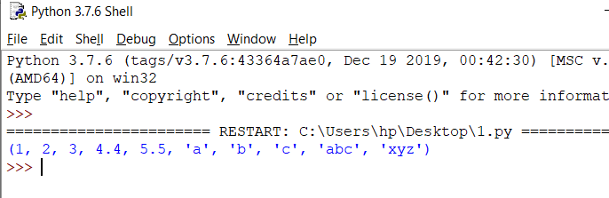

**PROGRAM 30.Write a python program to find the length of a tuple.**

t=(1,2,3,4.4,5.5,'a','b','c','abc','xyz')

length=len(t)

print("Length of the tuple is:",length)

**OUTPUT:**

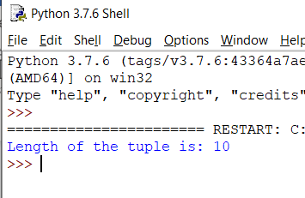

**PROGRAM 31.Write a python program to create a set**.

s={1,2,3,4.4,5.5,'a','b','c','abc','xyz'}

print(s)

**OUTPUT:**

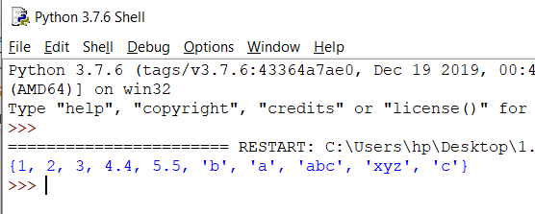

**PROGRAM 32.Write a python program to add member(s) in a set.**

s={1,2,3,4.4,5.5,'a','b','c','abc','xyz'}

s.add(10)

s.add(15)

print(s)

**OUTPUT:**

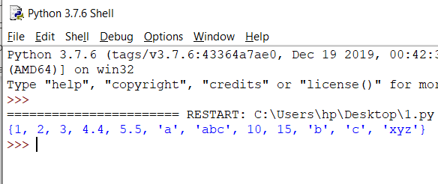

**PROGRAM 33.Write a python program to remove item(s) from set.**

s={1,2,3,4.4,5.5,'a','b','c',10,15,'abc','xyz'}

s.remove(10)

s.remove(15)

print(s)

**OUTPUT:**

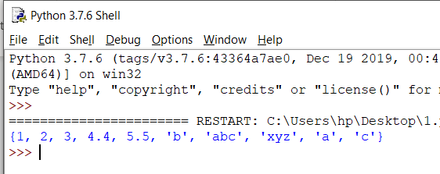

**PROGRAM 34.Write a python program to create an intersection of sets.**

s1={1,2,3,4,5,6}

s2={5,6,7,8,9,10}

intersection_set=s1&s2

print(intersection_set)

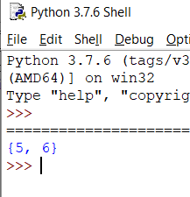

**PROGRAM 35.Write a python program to create an union of sets**.

s1={1,2,3,4,5,6}

s2={5,6,7,8,9,10}

union_set=s1|s2

print(union_set)

**OUTPUT:**

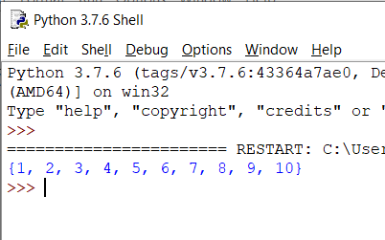

**PROGRAM 36.Write a python program to create set difference.**

s1={1,2,3,4,5,6}

s2={1,5,6}

difference_set=s1-s2

print(difference_set)

**OUTPUT:**

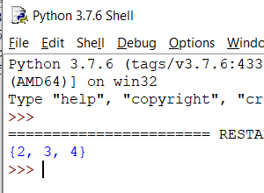

**PROGRAM 37.Write a python program to clear a set.**

s={1,2,3,4,5,6}

s.clear()

print(s)

**OUTPUT:**

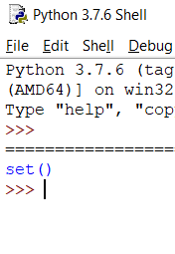

**PROGRAM 38.Write a python program to create dictionary.**

d={'name':'john','fav_game':'football','age':20}

print(d)

**OUTPUT:**

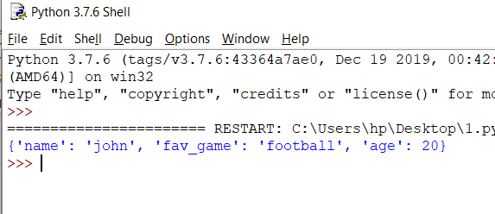

**PROGRAM 39.Write a python program to add a key to a dictionary.**

d={'name':'john','fav_game':'cricket','age':20}

d['fav_player']='AB De' #adding new key to dict

print(d)

**OUTPUT:**

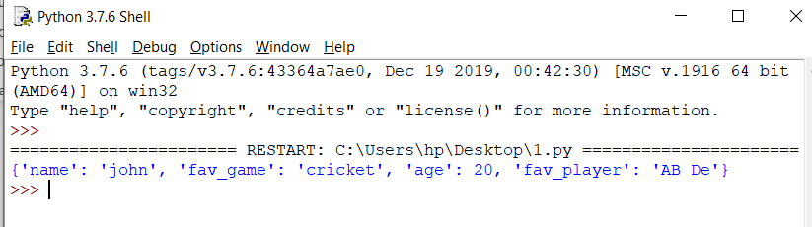

**PROGRAM 40.Write a python program to check whether a given key already exist in a dictionary.**

d={'name':'john','fav_game':'cricket','age':20,'fav_player':'AB de'}

if 'fav_game' in d:

print("PRESENT")

else:

print("NOT PRESENT")

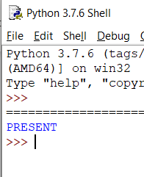

**PROGRAM 41.Write a python program to merge two python dictionaries.**

user_info1={'name':'abc','age':25,'DOB':"10/xy/abcd"}

user_info2={'father_name':'def','country':'ghi','state':'mno'}

user_info1.update(user_info2)

print(user_info1)

**OUTPUT:**

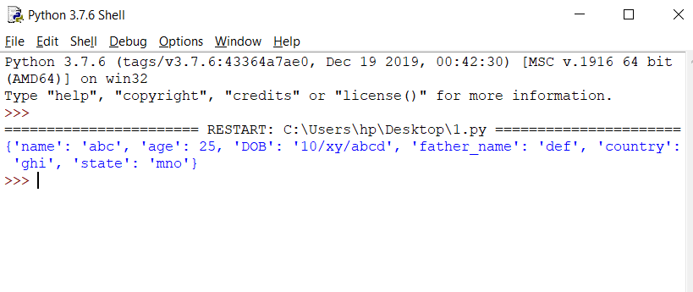

**PROGRAM 42.Write a python program to sum all the items in a dictionary.**

d={'a':10,'b':20,'c':30,'d':40,'e':50}

total=0

for i in d:

total+=d[i]

print("Sum of all the items is: ",total)

**OUTPUT:**

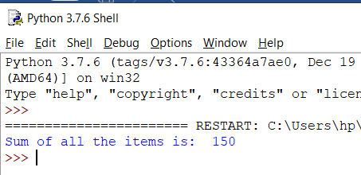

**PROGRAM 43.Write a python function to find average of five numbers passed parameters.**

def find_average(a,b,c,d,e):

average=(a+b+c+d+e)/5

return average

print(find_average(2,4,6,8,10))

**OUTPUT:**

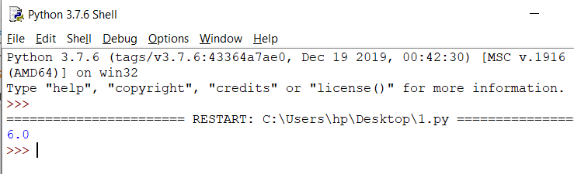

**PROGRAM 44.Write a python function to take list as argument and remove odd numbers from list.**

def list_func(list):

for i in list:

if i%2!=0:

list.remove(i)

print(list)

list=[1,2,3,4,5,6,7,8,9,10]

list_func(list)

**OUTPUT:**

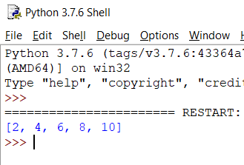

**PROGRAM 45.Write a python function to find fibonacci series upto to n terms.**

def fibonacci(num,a,b):

for i in range(0,num,1):

c=a+b

print(c,end=" ")

a=b

b=c

num=int(input("Enter the number "))

a=0

b=1

print(a,end=" ")

print(b,end=" ")

fibonacci(num,a,b)

**OUTPUT:**

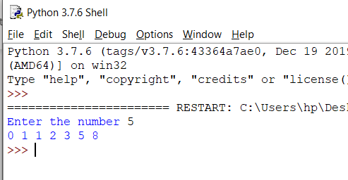

**PROGRAM 46.Write a python function to find factorial of a number.**

def factorial(num):

fact=1

total=0

for i in range(0,5,1):

total=fact*num

fact=total

num-=1

print("Factorial of a number is:",fact)

num=5

factorial(num)

**OUTPUT:**

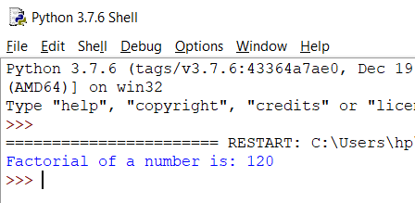

**PROGRAM 47.Write a python function to generate a table of any number entered by user.**

def table(num):

for i in range(1,11,1):

print(num ,"*", i,"=",num*i )

num=int(input("Enter the number "))

table(num)

**OUTPUT:**

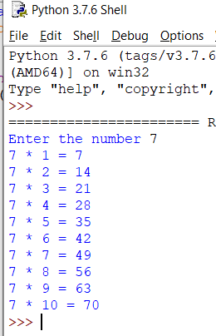

**PROGRAM 48. write a program to check whether given number is prime or composite.**

def prime(num):

if num > 1:

for i in range(2, num//2):

if (num % i) == 0:

c= 0

break

else:

c= 1

else:

c= 0

if c==0:

print(num, "is a composite number")

else:

print(num, "is a prime number")

prime(11)

**OUTPUT:**

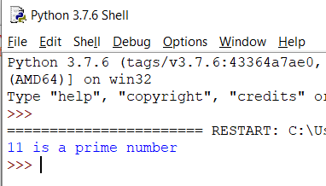

**PROGRAM 50.Write a python function to check whether input number is even or odd.**

def even_odd(num):

if num%2==0:

print("EVEN")

else:

print("ODD")

num=int(input("Enter the number "))

even_odd(num)

**OUTPUT:**

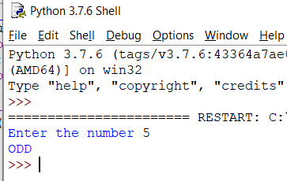

**PROGRAM 51.Write a python function to sum all the numbers in a list**.

def sum_all(list):

total=0

for i in list:

total+=i

print("Sum of all the list elements is:",total)

list=[1,2,3,4,5,6,7,8,9,10]

sum_all(list)

**OUTPUT:**

